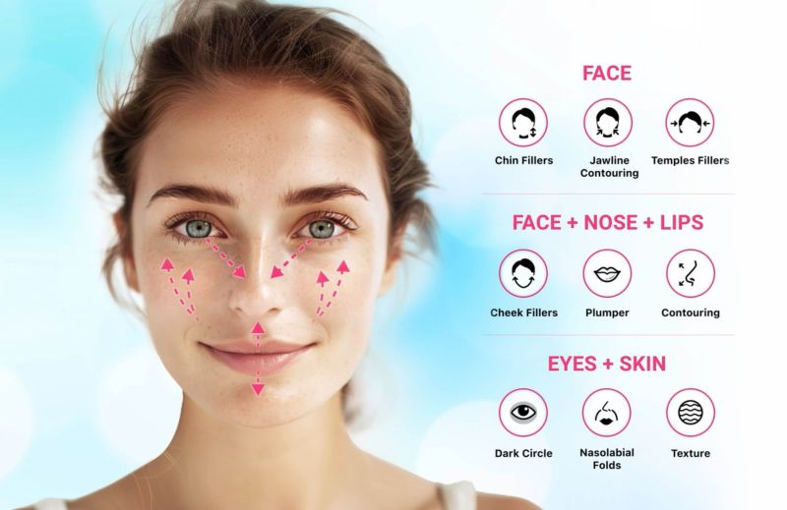

## **Project Objective**

To develop an AI-driven system that analyzes facial features from an image, measures attributes such as eye age, skin tone, wrinkles, redness, and uniformity, and generates a detailed skin health report with grading (e.g., Poor, Average, Good).

## **Technologies**

1. **Programming Language**: Python
2. **Libraries/Frameworks**:
   * **Deep Learning**: TensorFlow or PyTorch
   * **Image Processing**: OpenCV
   * **Facial Analysis**: Dlib, MediaPipe, or DeepFace
   * **Skin Analysis**: SciPy and OpenCV for skin segmentation
3. **Pre-trained Models**:
   * Face Detection: MediaPipe Face Detection, Haar Cascades, or YOLOv8.
   * Wrinkle Detection: Pre-trained CNNs or Mask R-CNN for skin texture analysis.
   * Eye Analysis: Vision Transformers (ViT) or EfficientNet for detecting fine details like puffiness or age-related markers.
4. **Visualization Tools**:
   * Matplotlib or Seaborn for generating the skin health report.
   * Streamlit or Flask for building an interactive user interface.
5. **Data Labeling Tools**: LabelImg or Roboflow for custom dataset creation.

## **Steps to Implement**

### **1. Data Collection**

* **Sources**: Use publicly available skin health datasets or create your dataset by annotating features such as wrinkles, redness, skin tone, etc.
* **Attributes** to Collect:
  + Skin tone (light, medium, dark)
  + Wrinkle density
  + Redness level
  + Eye features (puffiness, dark circles)
  + Uniformity of skin texture

### **2. Preprocessing**

* **Face Detection**: Detect and segment the face using MediaPipe or Dlib.
* **Region of Interest (ROI) Extraction**:
  + Extract specific areas: eyes, cheeks, forehead, etc.
  + Use facial landmarks to focus on zones like the T-zone or under-eye area.
* **Data Augmentation**: Apply rotation, scaling, and flipping to improve model generalization.

### **3. Model Selection**

#### **Facial Feature Classification**

* **Skin Tone**: Histogram-based classifier or ResNet for classification.
* **Wrinkles and Fine Lines**: Mask R-CNN or a custom CNN to identify wrinkle patterns.
* **Eye Features (Puffiness, Dark Circles)**:
  + Vision Transformers (ViT) or EfficientNet for fine-grained detection.
* **Redness and Uniformity**:
  + U-Net or DeepLabV3 for segmentation to detect uneven patches or redness.

#### **Pre-trained Models for Transfer Learning**

* VGG16, ResNet, or MobileNet for transfer learning on custom skin health datasets.

### **4. Grading System**

Define grading criteria for each feature:

* **Skin Tone Uniformity**:
  + *Good*: Uniform skin tone with no visible discoloration.
  + *Average*: Slightly uneven tone.
  + *Poor*: Noticeable discoloration or patchiness.
* **Wrinkles**:
  + *Good*: Minimal wrinkle presence.
  + *Average*: Moderate fine lines.
  + *Poor*: Deep wrinkles and visible fine lines.
* **Redness**:
  + *Good*: No redness.
  + *Average*: Mild redness in specific areas.
  + *Poor*: Widespread redness.
* **Eye Features**:
  + *Good*: No dark circles or puffiness.
  + *Average*: Moderate puffiness or mild discoloration.
  + *Poor*: Severe puffiness or dark circles.

Use thresholds derived from data distribution or expert dermatology input.

### **5. Training and Evaluation**

* **Loss Function**: Use binary cross-entropy for binary classification (e.g., good vs. poor) and categorical cross-entropy for multi-class grading.
* **Evaluation Metrics**: Accuracy, F1-Score, Precision, Recall for classification models.

### **6. Report Generation**

Generate a skin health report with:

* Numerical scores for each feature.
* Grading (Good, Average, Poor) based on thresholds.
* Recommendations for improvement (e.g., "Use sunscreen to reduce redness").

### **7. Deployment**

* **Interactive Web Application**:
  + Use **Streamlit** for a user-friendly interface.
  + Users can upload an image, and the app will display the extracted features, grades, and recommendations.
* **Cloud Hosting**: Deploy the app using AWS, Azure, or Google Cloud.

## **Workflow**

1. Upload image → Preprocess (face detection, feature segmentation) → Apply models for feature extraction → Generate scores → Map scores to grades → Visualize the report.

## **Challenges and Solutions**

1. **Low-quality images**:
   * Use high-resolution datasets and noise reduction techniques.
2. **Data imbalance**:
   * Oversample minority classes or use weighted loss functions.
3. **Fine-grained feature detection**:
   * Use high-capacity models like Vision Transformers or ensemble models.

## **Expected Outcome**

* A system that generates a skin health report, categorizes features into grades (Poor, Average, Good), and provides actionable insights for improvement.